Q1. What all packet aspects are covered in Single Pass Software?

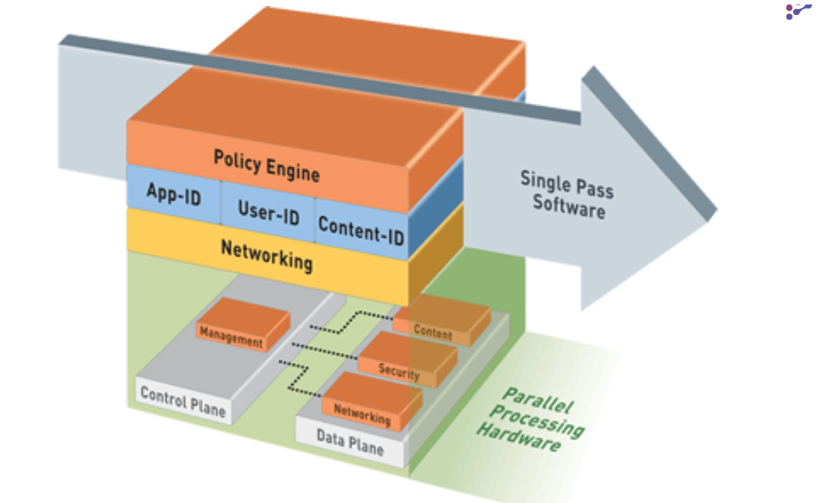

Ans: The Single Pass Software contributes to the high-throughput and low-latency nature of SP3 Architecture, It includes Policy Engine, App-ID, User-ID, Content-ID and Networking.

Policy Engine contains Security policies, NAT policies

App-ID is used to identify and block certain application traffic like primevideo etc…

User-ID is used to distinguish users with the help of user identities like username and user groups using directory services like AD, instead of just relying on IP addresses (which can be dynamic) in order to enforce security policies and generate logs.

Content-ID Scans the traffic for any threats like malware based on signatures by using UTM (Unified Threat Management)

Networking manages network functions such as Routing and NAT.

All of these things will be checked in a Single Pass the movement the packet enters the firewall, this contributes to the low-latency and high throughput as mentioned before.

Q2. What comes under the control plane and the data plane?

Ans: Parallel processing hardware divides its functions between Control Plane and Data Plane.

The Control Plane handles management of the firewall and The Data Plane handles the processing of the traffic through the firewall, each have their own resources and work independent of each other.

The Control Plane’s responsibilities include:

- Configuration of the firewall
- Checking and Installing updates
- License Management
- Logging
- Reporting
- Taking periodical back ups
- And many more

The some of the Data Plane’s responsibilities include:
‘
- Enforcing security policies
- Managing network functions such as routing, NAT, QoS etc..
- Scanning for malware using UTM
- Acts as a proxy between client and the server
- And many more

Q3. Life of a packet from ingress to egress in your own words

Ingress

In this the phase the packet is first received by the firewall and initializes ingress process, if there is an error it discards it, then it check if Firewall inspection is applicable to the packet if not skips to the egress process, if an inspection is applicable it checks if the packet originates from a VPN if so then decrypts and begins again from the ingress process, if not then the packet moves on to Fastpath.

Fastpath

Here firewall performs a session look up if one is not found then it moves the packet to slow path/session setup, if a session is found it processes and decrypts the packet if applicable, if a session match is identified the packet moves on to content inspection, if content inspection is not available it moves on to egress phase.

Slowpath/Session Setup

Here it performs forwarding lookup, NAT lookup, security policy look up if rule matches then it creates a session and moves on to content inspection else it discards the packet.

Application Identification

The firewall performs an pattern based application identification and performs security policy look up based on the application and performs content inspection setup if the application is SSL and decryption policy match then the session will be proxied else it will move on to egress

Content Inspection

It applies security policy and re-encrypts for SSL proxy if applicable then moves on to egress phase

Egress

The egress phase is where the packet leaves the firewall, exiting through a designated interface toward its its next hop or final destination, before it does that the firewall performs packet forwarding and egress process (QoS shaping, IP fragmentation, or tunnel encryption) if applicable and then transmits the packet.

